DANJO Managed Executive Properties, Inc.

931 S. Florida Avenue

Lakeland, FL 33803

PO Box 6402

Lakeland, FL 33807

(863) 646-3040 (863) 607-9645

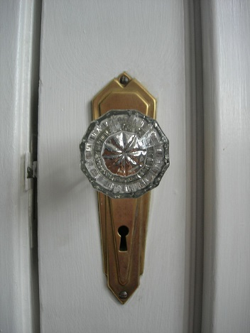

This page **must** accompany the application to be considered.

Address you are applying for _____________________________________________

Desired move-in date ___________________________________________________

* All applications must have credit report and 2 consecutive paystubs or proof of income to be processed. Failure to provide all necessary paperwork within 48 hours of application may result in loss of good faith deposit.
* If application is approved, deposit required within 24 hours to secure the home. Security Deposit MUST be in cashier’s check or money order form, made payable to DANJO.
* If the approved applicant fails to enter into a lease agreement for any reason, the entire Security Deposit shall be forfeited.
* Keys will be delivered upon receipt of first month’s rent and verification of utilities. First month’s rent MUST be in cashier’s check or money order made payable to DANJO.
* Multiple applications might be received on the property, if you have any questions please call the DANJO office at (863) 646-3040.

Do you have pets? ____ yes ____no (if yes, include information on application, $300 pet fee unless otherwise stated)

Signature ___________________________________________________ Date ____________________________

Signature ___________________________________________________ Date ____________________________

All Applications must be accompanied by:

Signatures for all adult applicants

Legible copies of potential tenant ID’s (driver’s license and social security number)

**INCOMPLETE APPLICATIONS WILL NOT BE PROCESSED!**

**Send completed form to danjo2@aol.com**